**LABTASK 8**

**NAME: SARIM AMIR**

**SID: 63686**

**LINEAR REGRESSION CODE:**

import numpy as np  
import matplotlib.pyplot as plt  
  
def estimate_coef(x, y):  
 n = np.size(x)  
 m_x = np.mean(x)  
 m_y = np.mean(y)  
 SS_xy = np.sum(y * x) - n * m_y * m_x  
 SS_xx = np.sum(x * x) - n * m_x * m_x  
 b1 = SS_xy / SS_xx  
 b0 = m_y - b1 * m_x  
 return (b0, b1)  
  
def plot_regression_line(x, y, b):  
 plt.scatter(x, y, color="m", marker="o", s=30)  
 y_pred = b[0] + b[1] * x  
 plt.plot(x, y_pred, color="g")  
 plt.xlabel('x')  
 plt.xlabel('y')  
 plt.show()  
def main():  
 x = np.array([5, 7, 8, 7, 2, 17, 2, 9, 4, 11, 12, 9, 6])  
 y = np.array([99, 86, 87, 88, 111, 86, 103, 87, 94, 78, 77, 85, 86])  
 b = estimate_coef(x, y)  
 print("Estimated coeefficient:\nb_0 = {}\nb_1 = {}".format(b[0], b[1]))  
 plot_regression_line(x, y, b)  
if __name__ == "__main__":  
 main()

**OUTPUT:**

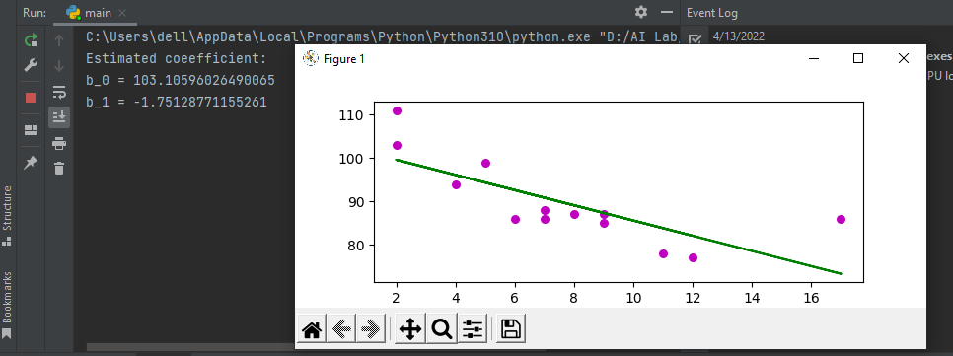

**LOGISTIC REGRESSION CODE:**

import pandas as pd  
from sklearn.model_selection import train_test_split  
from sklearn.linear_model import LogisticRegression  
from sklearn import metrics  
import numpy as np  
import matplotlib.pyplot as plt  
import seaborn as sns  
  
data = pd.read_csv('dataset.csv')  
X=data[['X']]  
Y=data.Y  
X_Train, X_Test, Y_Train, Y_Test = train_test_split(X, Y, test_size = 0.25, random_state = 0)  
logreg = LogisticRegression()  
logreg.fit(X_Train,Y_Train)  
y_pred=logreg.predict(X_Test)  
  
cnf_matrix = metrics.confusion_matrix(Y_Test, y_pred)  
cnf_matrix  
  
class_names=[0,1] # name of classes  
fig, ax = plt.subplots()  
tick_marks = np.arange(len(class_names))  
plt.xticks(tick_marks, class_names)  
plt.yticks(tick_marks, class_names)  
# create heatmap  
sns.heatmap(pd.DataFrame(cnf_matrix), annot=True, cmap="YlGnBu" ,fmt='g')  
ax.xaxis.set_label_position("top")  
plt.tight_layout()  
plt.title('Confusion matrix', y=1.1)  
plt.ylabel('Actual label')  
plt.xlabel('Predicted label')  
print("Accuracy:",metrics.accuracy_score(Y_Test, y_pred))  
print("Precision:",metrics.precision_score(Y_Test, y_pred,average='micro'))  
print("Recall:",metrics.recall_score(Y_Test, y_pred,average='micro'))  
  
y_pred_proba = logreg.predict_proba(X_Test)[::,1]  
fpr, tpr, _ = metrics.roc_curve(Y_Test, y_pred_proba,pos_label='your_label')  
auc = metrics.roc_auc_score(Y_Test, y_pred_proba)  
plt.plot(fpr,tpr,label="data 1, auc="+str(auc))  
plt.legend(loc=4)  
plt.show()

**DATASET:**

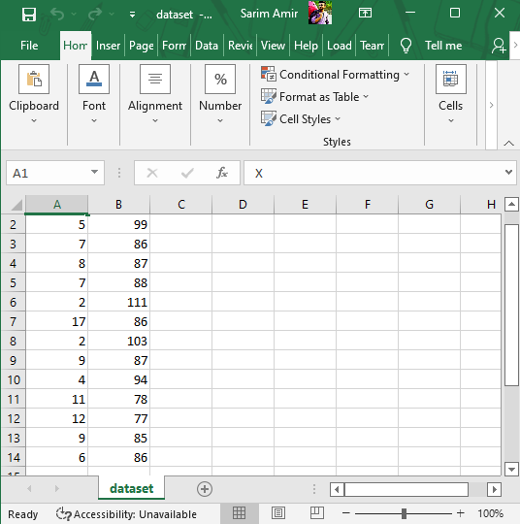

**OUTPUT:**

